

Daniel in the Lion’s Den

**___**

Daniel 6: 10-28 (NRSV)

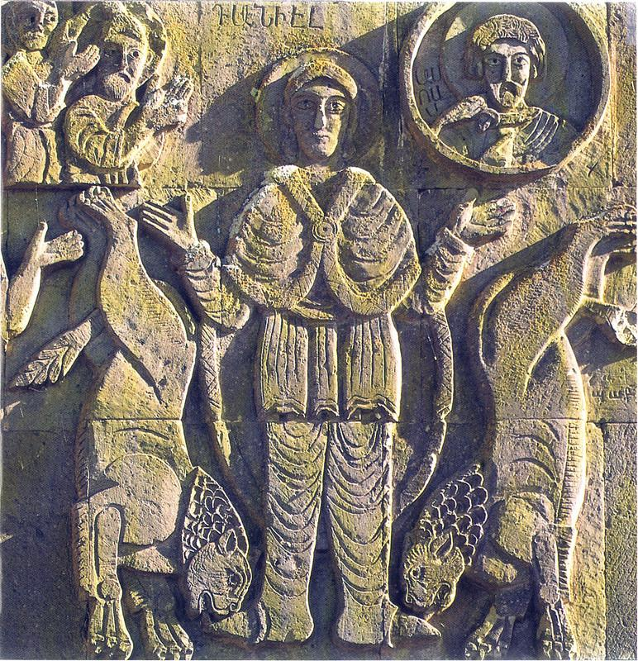

10th Century bas-relief image of Daniel in the Lion’s Den found at The Holy Cross Church in Akhtamar Island near Lake Van.

## Ice Breakers:

1. My favorite food is…. Why?
2. My favorite time of day is...Why?
3. The person I go to when I have something important to share is…
4. If I found a wallet full of cash on the street I would….

## The Word of God:

“It pleased Darius to set over the kingdom one hundred twenty satraps, stationed throughout the whole kingdom, and over them three presidents, including Daniel; to these the satraps gave account, so that the king might suffer no loss. Soon Daniel distinguished himself above all the other presidents and satraps because an excellent spirit was in him, and the king planned to appoint him over the whole kingdom. So the presidents and the satraps tried to find grounds for complaint against Daniel in connection with the kingdom. But they could find no grounds for complaint or any corruption, because he was faithful, and no negligence or corruption could be found in him. The men said, “We shall not find any ground for complaint against this Daniel unless we find it in connection with the law of his God.” So the presidents and satraps conspired and came to the king and said to him, “O King Darius, live forever! All the presidents of the kingdom, the prefects and the satraps, the counselors and the governors are agreed that the king should establish an ordinance and enforce an interdict, that whoever prays to anyone, divine or human, for thirty days, except to you, O king, shall be thrown into a den of lions...Therefore King Darius signed the document and interdict. Although Daniel knew that the document had been signed, he continued to go to his house, which had windows in its upper room open toward Jerusalem, and to get down on his knees three times a day to pray to his God and praise him, just as he had done previously. The conspirators came and found Daniel praying and seeking mercy before his God...Then the king gave the command, and Daniel was brought and thrown into the den of lions. The king said to Daniel, “May your God, whom you faithfully serve, deliver you!” A stone was brought and laid on the mouth of the den, and the king sealed it with his own signet and with the signet of his lords, so that nothing might be changed concerning Daniel. ” -Daniel 6:1-8,9-11,16-17

### How did Daniel get appointed for an important position in all the kingdom?

* 1. He had friends to recommend him for the job.
  2. He worked with excellence.
  3. He worked with no corruption.
  4. He was faithful.
  5. Other

### Why were the other leaders (presidents and satraps) trying to find fault with Daniel?

* 1. They were jealous of Daniel.
  2. They wanted Daniel’s position.
  3. They didn’t think he was qualified.
  4. They thought he wasn’t in the position long enough to deserve a promotion.
  5. Other

### Talk about a time when you were working towards a specific role or position.

* 1. Were others supportive of your accomplishments?
  2. Were you acknowledged for your efforts or overlooked?
  3. How did others’ behavior towards you impact your performance? Was it harder, easier or the same?
  4. Other

### If there was a law stating you had to worship a false god how likely would you be to comply? Explain.

* 1. Very likely- it’s the law. I don’t want to go to jail and have a criminal record.
  2. Somewhat likely- it’s the law but I don’t agree with it.
  3. Somewhat unlikely- it’s against what I believe
  4. Very unlikely- I won’t be told how or what to believe regardless of the consequences.

### Why do you think Daniel continued to pray to God even though there was a law against it?

* 1. He thought the King wouldn’t punish him.
  2. Daniel didn’t respect authority.
  3. Daniel knew he needed God’s mercy more than ever to face his current situation.
  4. He valued God’s laws above the law of the land.
  5. Other

### Talk about a time in your life (or the life of a friend) when standing up for your faith was a challenge or unpopular thing to admit.

* 1. Did you hesitate about sharing that you are a Christian? Why?
  2. Did you suffer any hardship for sharing?
  3. Were you respected or ridiculed for your beliefs?
  4. Was it hard being different than those around you?
  5. Other

## Commit:

Which of the following will you commit to doing this week?

1. Pray that God will give me courage like Daniel to do the right thing regardless of the consequences I may face.
2. Stand up for someone who is outnumbered in a group.
3. Pray that God will help those who are unjustly treated because of their faith.
4. Reread the entire story of Daniel in chapter six.
5. Look for acts of courage around you and encourage someone who has acted courageously to defend his/her faith.
6. Other

### Prayer:

1. Pray for any specific needs your group or members may want to pray about..
2. Close with Hayr Mer...