

David and Goliath

**___**

1Samual 17 (NRSV)

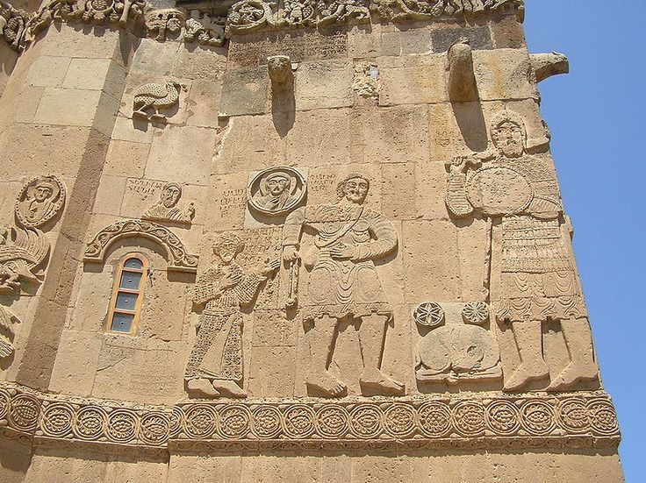

10th century bas-relief image on side of Cathedral Church of the Holy Cross, Aghtamar Island near Lake Van (stock image)

## Ice Breakers:

1. My favorite board game to play is...
2. The easiest tests in school for me are...
3. One thing my grandparents taught me is...
4. One childhood event that taught me the most valuable lesson is...

# The Word of God:

“David said to Saul, “Let no one’s heart fail because of him; your servant will go and fight with this Philistine.” Saul said to David, “You are not able to go against this Philistine to fight with him; for you are just a boy, and he has been a warrior from his youth.” But David said to Saul, “Your servant used to keep sheep for his father; and whenever a lion or a bear came, and took a lamb from the flock, I went after it and struck it down, rescuing the lamb from its mouth; and if it turned against me, I would catch it by the jaw, strike it down, and kill it. Your servant has killed both lions and bears; and this uncircumcised Philistine shall be like one of them, since he has defied the armies of the living God.” David said, “The Lord, who saved me from the paw of the lion and from the paw of the bear, will save me from the hand of this Philistine.” So Saul said to David, “Go, and may the Lord be with you!” Saul clothed David with his armor; he put a bronze helmet on his head and clothed him with a coat of mail. David strapped Saul’s sword over the armor, and he tried in vain to walk, for he was not used to them. Then David said to Saul, “I cannot walk with these; for I am not used to them.” So David removed them. Then he took his staff in his hand, and chose five smooth stones from the wadi, and put them in his shepherd’s bag, in the pouch; his sling was in his hand, and he drew near to the Philistine. When the Philistine looked and saw David, he disdained him, for he was only a youth, ruddy and handsome in appearance. But David said to the Philistine, “You come to me with sword and spear and javelin; but I come to you in the name of the Lord of hosts, the God of the armies of Israel, whom you have defied. This very day the Lord will deliver you into my hand, and I will strike you down and cut off your head; and I will give the dead bodies of the Philistine army this very day to the birds of the air and to the wild animals of the earth, so that all the earth may know that there is a God in Israel, and that all this assembly may know that the Lord does not save by sword and spear; for the battle is the Lord’s and he will give you into our hand.” David put his hand in his bag, took out a stone, slung it, and struck the Philistine on his forehead; the stone sank into his forehead, and he fell face down on the ground. So David prevailed over the Philistine with a sling and a stone, striking down the Philistine and killing him; there was no sword in David’s hand. Then David ran and stood over the Philistine; he grasped his sword, drew it out of its sheath, and killed him; then he cut off his head with it. When the Philistines saw that their champion was dead, they fled.” -1 Samuel 17:32-40,42,45-47,49-51 (NRSV)

### Why did people think David couldn’t defeat Goliath?

* 1. Goliath was huge!
  2. David was a young boy with little to no experience as a soldier.
  3. Goliath was an experienced warrior who had already defeated so many other skilled soldiers.
  4. David didn’t want to wear the protective armor before going into battle.
  5. The risks were too high: The fate of Israel rested on this one battle.
  6. Other?

### Why do you think David had confidence he could defeat Goliath?

* 1. David was used to defending his sheep from wild animals.
  2. David remembered how God had helped protect him in the past while fighting off wild animals.
  3. David would not allow a foreigner to defy or insult The Living God.
  4. David knew he would defeat Goliath not by relying on his own strength and skill but by trusting in God.
  5. David would use the tools and experiences God had already given him in his daily life to overcome this new challenge.
  6. Other?

### What are some of the “giants” you or your friends face?

* 1. Academics- pressure to get good grades as you prepare for your future
  2. Standing up for others who are being treated unfairly
  3. Vaping
  4. Holding on to your Armenian Christian values when most people around you don’t understand
  5. Parents’ expectations/standards
  6. Other

### What are some of the “tools” or experiences God has placed in your “pocket” to help you defeat your giants?

* 1. The Bible and God’s promises for me.
  2. Prayer- I can call on God whenever or wherever I am
  3. A sound mind to know when something doesn’t seem right.
  4. My personal experience with or talent(s) of…….
  5. A loving Armenian Church community (and this Salt & Light group) that I belong to
  6. Other

## Commit:

Which of the following will you commit to doing this week?

1. Read the entire passage about David and Goliath in 1 Samuel 17.
2. Ask God to show you more of the “tools” He’s given you and thank Him for blessing you with them.
3. Use a talent you have to bless someone else this week.
4. Find someone in your church community you can thank for helping you feel accepted and loved.
5. Other?

### Prayer:

1. Pray for any specific needs your group may want to pray about.
2. Close with Hayr Mer…