### 

### **Formed.org New Login Procedure**

### **Revised September 2019**

1. Please go to FORMED.org. Click Sign up.



1. Click the “I belong to a parish or organization” tab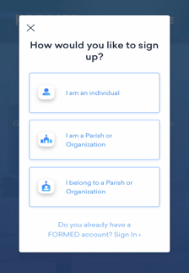
2. Enter “Eastern Prelacy of the Armenian Apostolic Church” In the “ Find your parish or Organization “ field. Our Prelacy name should automatically pull up. Click to select it.

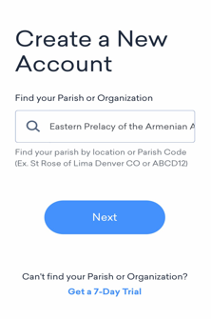

1. Finally enter your name and email address in the designated fields.