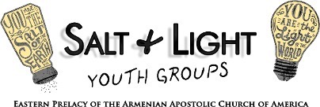

Suit Up!

**___**

Ephesians 6:10-18 (NRSV)

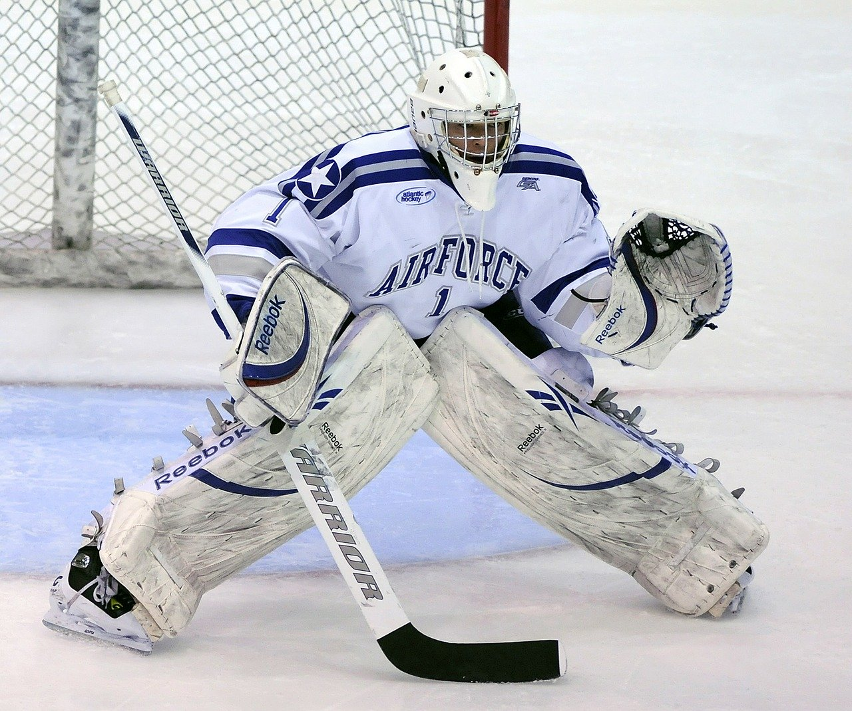

## Ice Breaker:

The Word Chain Game:

In this word game, players have to come up with words that begin with the letter that the previous word ended. The words must match, not only the letters, but also the category in question. So if one person says the word “cat” (category “animals”), the next person has to say a word that starts with “t” and falls in the category “animals”, such as “tiger.” The only two rules are: 1. You have five seconds to come up with a name. 2. You can’t repeat words. Any word works to begin. Here are a few to get you started: rainbow, hammer, helmet.

# The Word of God: Ephesians 6:10-18

“**10** Finally, be strong in the Lord and in the strength of his power. **11** Put on the whole armor of God, so that you may be able to stand against the wiles of the devil. **12** For our struggle is not against enemies of blood and flesh, but against the rulers, against the authorities, against the cosmic powers of this present darkness, against the spiritual forces of evil in the heavenly places. **13** Therefore, take up the whole armor of God, so that you may be able to withstand, on that evil day, and having done everything, to stand firm. **14** Stand therefore, and fasten the belt of truth around your waist, and put on the breastplate of righteousness. **15** As shoes for your feet put on whatever will make you ready to proclaim the gospel of peace. **16** With all of these, take the shield of faith, with which you will be able to quench all the flaming arrows of the evil one. **17** Take the helmet of salvation, and the sword of the Spirit, which is the word of God. **18** Pray in the Spirit at all times in every prayer and supplication. To that end keep alert and always persevere in supplication for all the saints.”- Ephesians 6:10-18 (NRSV)

### Think of the uniform of an ice hockey goalie as pictured above. Why does the athlete wear each piece of his/her equipment?

* 1. The uniform identifies the player’s team and position.
  2. The pads help diffuse the impact of the hits.
  3. The size of the pads and stick of the goalie provide a greater range of protection.
  4. The helmet and mouthguard protect his/her head from brain injury.
  5. The proper foot gear helps the goalie move around quickly without falling.
  6. The added protection provides additional confidence for the athlete to charge the offensive attacks.
  7. other?

### What would happen if the goalie forgot to wear one piece of protective gear? Two or more?

* 1. He or she would have a greater chance of getting injured.
  2. The goalie would have to compensate for the missing gear by overusing another part of his/her body.
  3. The goalie would be less confident to protect the goal and team.
  4. The whole team would receive a penalty or get disqualified from the game.
  5. Other?

### Like sports equipment, spiritual equipment, or armor, protects us in battle. How is being an Armenian Christian in our society like being in a war?

* 1. My family’s beliefs are different from those of other families.
  2. People around me do not understand why I celebrate certain holidays on certain days like Armenian Christmas.
  3. Culture tells us certain things are “OK” even though they are harmful to me physically or spiritually.
  4. My values are often attacked as being old fashioned or outdated.
  5. Other?

### What are the various pieces of armor St. Paul highlights in the above passage? How does each piece of armor protect us spiritually?

* 1. **Belt of Truth**- knowing the truth helps me remain centered so I can identify a lie when I hear one.
  2. **Breastplate of Righteousness**- acting honestly, decently and with integrity prevents me from causing pain to myself and others.
  3. **Shoes of Peace**- wearing the Gospel of Peace or taking the “higher road” and choosing Christ’s peace for myself and others.
  4. **Shield of Faith**-to extinguish the flaming attacks of the evil one
  5. **Helmet of Salvation**- God’s salvation is an ongoing event that His children enjoy now and eternally. Because of the cross, the enemy no longer has a hold on me.
  6. **Sword of the Spirit**- the Word of God- knowing it, trusting and relying on it.
  7. **Prayer**- praying in all situations for myself and others

### Why do we need to put on our full armor of God?

* 1. We need full protection against the enemy’s attacks.
  2. The armor strengthens me as verse one states, “be strong in the Lord, and in the strength of His power.”
  3. “That you may be able to stand firm against the schemes of the devil,” verse 2.
  4. Our struggle is not against people but against forces, powers of darkness and spiritual forces of wickedness in heavenly places.
  5. We need tools to proactively prevent assault.
  6. The armor helps me resist evil by standing strong in what matters and what is right.
  7. Other?

### If you could pick one piece of your personal armor to work on or strengthen, which would you choose and why?

* 1. **Belt of Truth**- I could be better grounded in what is true instead of listening to lies told about me or my worth.
  2. **Breastplate of Righteousness-** I can choose to do what’s right, honest, decent even when nobody's looking.
  3. **Shoes of Peace**- I can choose to give others the benefit of the doubt if they offend me.
  4. **Shield of Faith**- I can trust the truths that God loves me, He is good and He is with me always.
  5. **Helmet of Salvation**- I can believe that as a child of God nothing or no one can ever separate me from the love of God.
  6. **Sword of the Spirit**- I can decide to read the Word of God, Bible, daily so I can know, trust and rely on its truths more each day.
  7. **Prayer**- I can decide to pray more regularly for both my needs and those of others.

## Commit:

Which of the following will you commit to doing until our next session?

1. Reread the entire sixth chapter of Ephesians.
2. Pray that the Holy Spirit will reveal areas of your armor that may need to be strengthened.
3. Choose one of the pieces of armor and pray that our Lord will help you grow in its truth.
4. Listen to and read the lyrics of the Song, “Battles” by Jordan Smith, 2015 winner of The Voice.
5. During the Sacrament of Chrismation at Baptism, the priest anoints nine parts of the baby (or adult’s) body. What are the parts and why would our church fathers include these parts during the Sacrament?
6. Before beginning Soorp Badarak, the priest wears pieces of his vestment. What are the pieces? What are the prayers he says as he wears each piece? Why do you think our church fathers have included these prayers before the start of Soorp Badarak? How is this related to today’s lesson?

### Prayer:

1. Pray for any individual needs.
2. Close by praying St. Nerses Shnorhali’s, In Faith I Confess prayer #14:

Khunamogh araradzots, bahya nu­shanav khachi ko uz-hoki yev uzmarmin im i badranats meghats, i portsootyants tivats, yev i martots aniravats, yev hame­nayn vudankits hokvo yev marmno, yev voghormya ko araradzots yev ints paz­mameghis.

Protector of all creatures, by the sign of your cross keep my soul and body from the allurements of sin, from the temptations of evil spirits, from unjust men, and from all perils of soul and body. Have mercy upon your creatures, and upon me, great sinner that I am.