

The Parable of   
The Pharisee and the Tax Collector

**___**

Luke 18:9-14 New Revised Standard Version (NRSV)

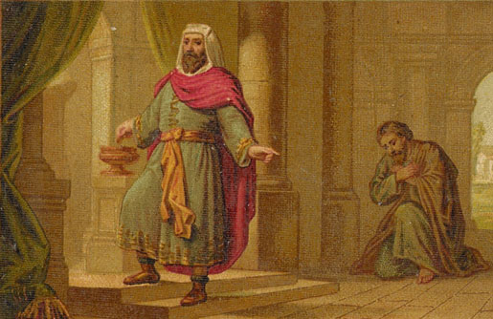

# The Word of God

***The Parable of the Pharisee and the Tax Collector***

*He also told this parable to some who trusted in themselves that they were righteous and regarded others with contempt: “Two men went up to the temple to pray, one a Pharisee and the other a tax collector. The Pharisee, standing by himself, was praying thus, ‘God, I thank you that I am not like other people: thieves, rogues, adulterers, or even like this tax collector. I fast twice a week; I give a tenth of all my income.’ But the tax collector, standing far off, would not even look up to heaven, but was beating his breast and saying, ‘God, be merciful to me, a sinner!’ I tell you, this man went down to his home justified rather than the other; for all who exalt themselves will be humbled, but all who humble themselves will be exalted.” (Luke 18:9-14 )*

## Introduction

This parable is about two very different men. The Pharisee was from a religious sect whose prime concern was keeping the law of the Old Testament. The tax collector was in a profession where many were considered traitors and thieves, because they collected taxes for the Romans from their fellow Jews –usually with great personal profit.

### Optional Ice-Breaker Questions:

* Where is your favorite place to pray?
* What experience was especially humbling for you recently?

### Reflection Questions:

**1. Why do you think the Pharisee acted the way he did?**

* A) He was grateful to God.
* B) He was self-righteous.
* C) He wanted to honor God.
* D) He wouldn't be real with himself.
* Other ––––––––––––––––––––––

**2. Why do you think the tax collector acted the way he did?**

* A) He knew he had done wrong.
* B) He wanted sympathy.
* C) He had a poor self-image.
* D) He was plea bargaining with God.
* E) He had hit rock bottom.
* Other ––––––––––––––––––––––

**3. What lesson about our prayer attitude is Jesus teaching us here?**

* A) God despises self-righteousness.
* B) God loves/welcomes humble repentance.
* C) God knows what's in our hearts.
* D) Prayer is private.
* E) God wants us to be sincere.
* Other ––––––––––––––––––––––

**4. How would you welcome the tax collector as a friend in your life? How about the Pharisee?**

* A) With suspicion.
* B) With open arms.
* C) With conditions.
* D) Like I have been.
* Other ––––––––––––––––––––––

**5. How much of the Pharisee and the collector do you see in yourself? Put a percentage for each that adds up to 100%.**

I see myself as –––% Pharisee and –––% tax collector.

**6. In each of the following statements, which option is closer to how you see yourself?**

* A) I make excuses for my faults.
* B) I take responsibility for my faults.
* C) I put myself down.
* D) I see myself like God does.
* E) I have a defeating attitude.
* F) I have a confident attitude.

**7. What is the lesson that this parable teaches you?**