

Walking on Water!

**___**

Matthew 14: 22-33 (NRSV)

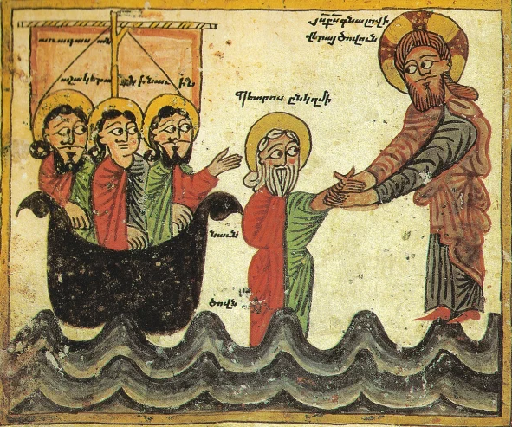

## Ice Breakers:

1. Would you rather swim in a kiddie pool with 100 toddlers or swim in a beach/lake among thousands of fish?
2. Would you rather take a shower with warm chocolate syrup or take a bath in a tub of ice cubes?
3. Would you rather watch Summer Olympics’ water polo or synchronized swimming?
4. Would you rather have a pet snake or a pet alligator?
5. What is something that really scared you when you were a kid?

## The Word of God:

**22** Immediately he made the disciples get into a boat and go on ahead to the other side, while he dismissed the crowds. **23** And after he had dismissed the crowds, he went up the mountain by himself to pray. When evening came, he was there alone, **24** but by this time the boat, battered by the waves, was far from the land, for the wind was against them. **25** And early in the morning he came walking toward them on the sea. **26** But when the disciples saw him walking on the sea, they were terrified, saying, “It is a ghost!” And they cried out in fear. **27** But immediately Jesus spoke to them and said, “Take heart, it is I; do not be afraid.” **28** Peter answered him, “Lord, if it is you, command me to come to you on the water.” **29** He said, “Come.” So Peter got out of the boat, started walking on the water, and came toward Jesus. **30** But when he noticed the strong wind, he became frightened, and, beginning to sink, he cried out, “Lord, save me!” **31** Jesus immediately reached out his hand and caught him, saying to him, “You of little faith, why did you doubt?” **32** When they got into the boat, the wind ceased. **33** And those in the boat worshiped him, saying, “Truly you are the Son of God.”

-Matthew 14: 22-33 (NRSV)

### Put the events from the passage in order.

* 1. ______Jesus reaches out and catches Peter.
  2. ______The disciples worship Jesus.
  3. ______Peter notices the strong wind, gets scared and sinks.
  4. ______The strong waves and winds drift the boat away from the shore.
  5. ______Jesus gets in the boat
  6. ______Peter asks to join Jesus on top of the water.
  7. ______The disciples are alone all night in the boat.
  8. ______Jesus welcomes Peter on the water.
  9. ______Peter walks on the water.
  10. ______The wind stops.

### Why do you think Peter left the boat?

* 1. He wanted to make sure it was Jesus on the water and not a ghost.
  2. The boat was so unstable and uncomfortable he had to get out.
  3. The other apostles were so scared and complaining too much he couldn’t deal with them anymore.
  4. It was worth risking encountering a ghost because if it was Jesus He would know what to do.
  5. Peter trusted Jesus, who He is, and what He is capable of doing.
  6. Other?

### What do you think the other disciples were doing?

* 1. They were huddling in fear in a corner of the boat.
  2. They were arguing over who didn’t steer the boat correctly during the night.
  3. They were nominating Peter to go figure out if it’s really Jesus on the water or if it’s a ghost.
  4. They were saying Peter was crazy for attempting to do what he was about to do.
  5. They were doing nothing.

### Which character do you identify with the most?

* 1. Peter: I want proof it’s Jesus regardless of the risk.
  2. Jesus: I’m always calming others or reassuring them about the truth.
  3. The other disciples: Let Peter figure out if that’s a ghost or not; I’m staying here on this shaky boat with the others. It’s not great here but at least we’re together.
  4. None of them: If Jesus isn’t getting on the boat with us on shore I’m not heading out on the sea.
  5. Other?

### Referring back to the fifth Ice Breaker question, what would your parents or other trusted adults do when you were afraid?

* 1. Reassure me everything was ok.
  2. Pull me close or hug me so I would feel safe.
  3. “Punish” the object that was frightening me.
  4. Scold me for being afraid.
  5. Do nothing/ ignore me.
  6. Other?

### How does Jesus address the fear of Peter and the other disciples?

* 1. He immediately reassures them He’s not a ghost.
  2. He invites Peter out on the water close to Him.
  3. He questions Peter why he doubted.
  4. He holds on to Peter when he gets frightened again.
  5. His mere presence silenced the storm.
  6. Other?

### The section inside an Armenian Apostolic church where the people sit on pews is called the Nave (from the Latin, NSavus,) Interestingly, the word “Nahv” in Armenian means boat. How are we reminded we are like the apostles everytime we enter the church building?

* 1. As we recall the storms we were facing during the week, on Sunday, we are reminded who Jesus is and how He alone is able to calm all the storms in our lives.
  2. When we focus on Christ, we can walk above all our challenging circumstances without feeling like we’re sinking.
  3. When we enter church we are traveling to get closer to The Father, Son and Holy Spirit, by recalling all God has done, is doing, and will do for all who believe in Him.
  4. We do not have to live hidden in fear. Worshiping Jesus, especially in Soorp Badarak, helps us recall who we are as His children and followers and that He is with us through Holy Communion.
  5. We’re reminded we are on a journey and Christ Jesus meets us where we are, welcoming us to draw closer to Him and always willing to help pull us up when we feel overwhelmed.
  6. We are reminded we are not alone on the “boat” but with others on this faith journey.
  7. Other?

## Commit:

Which of the following will you commit to doing this week?

1. Listen to the song entitiled, Walking on Water by NEEDTOBREATH.
2. Write down a prayer in your journal that confesses any fear that is distracting you from staying focused on getting closer to Christ and His will. Pray that God will help you realize He is able and willing to calm that storm in your life.
3. Commit to attend Soorp Badarak and receive Holy Communion each week this month recalling how you are on a “boat ride” where Christ is inviting you to draw closer to Him.
4. Reread the entire fourteenth chapter of the Gospel of Matthew.
5. Identify two people in your life who you can encourage to “journey” with you to church or Salt & Light. Ask if he/ she is willing to hold you accountable to attend. Write down his or her name. Be prepared to share what happened at your next small group meeting.
6. Watch the walking on water movie clip from *The Chosen* drama series, https://www.youtube.com/watch?v=kyZkMpaaYAo
7. Other?

### Prayer:

1. Pray for any specific needs your group or members may want to pray about..
2. Close with Hayr Mer…